School Of computing

Practical 4: Control Structures (Selection)

What you will learn / do in this lab

- Use if statements
- Use switch statements
ST0502 Fundamentals of Programming

1. Write a program that will take in 2 numeric values and display the bigger of the 2 numbers as shown below. The program should also display relevant message when the 2 numbers are equal.

You can make reference to the Appendix A logic flowchart (Raptor) to code your program.

Sample output:
Please enter 1st number: 12
Please enter 2nd number: 7

1st number is bigger

2. The following table illustrates the cutoff scores for the various academic grades in SP. Write a program Grade that will prompt the student for his score and your program should display his grade.

You can make reference to the Appendix B logic flowchart (Raptor) to code your program.

score | grade
80 and above | A
70 to less than 80 | B
60 to less than 70 | C
50 to less than 60 | D
Less than 50 | F

Sample program output:
Please enter score: 73.5
Your grade is B

Note: Create the logic flow in Raptor before attempting to code the program in JavaScript.

3. Write a program CheckNumber that prompts the user to enter an integer and checks whether the number is divisible by both 5 and 6, either or just one of them. Below are some sample output for input values 10, 30 and 27 respectively.

Sample output:
Sample #1
Enter an integer: 10
10 is divisible by 5 or 6, but not both.

Sample #2
Enter an integer: 30
30 is divisible by both 5 and 6.

Sample #3
Enter an integer: 27
30 is not divisible by either 5 or 6.

4. Company X revises the increment to the salary of a staff based on the following criteria. For example, if a staff has worked for less than 10 years and is earning a salary of $1999, he would get an increment of $200.

years | salary | increment
Less than 10 | Less than $1000 | $100
Less than 10 | Less than $2000 | $200
Less than 10 | $2000 or more | $300
10 or more | Less than $1000 | $200
10 or more | Less than $2000 | $300
10 or more | $2000 or more | $400

Write a program IncrementCalculator that will prompt for 2 integer values which represent years of service and salary of a staff. The program will then display the increment of the staff. You are to implement the logic using if statements.

Sample output:
Please enter your year of service: 15
Please enter your salary: 2000.5
Your increment is $400

5. The following table shows the prize money for the SP Idol contestants.

Rank | Prize Money ($)
1 | 1000
2 | 800
3 | 700
4 | 300
5 | 300
Others | 20

Write a program PrizeMoney that will prompt for the rank of the contestant and your program should display his prize money. You are to implement the logic using switch statements.

Sample output:
Please enter your rank: 3
Your prize money is $700.

6. (Optional question) A bicycle rental company “Speed Wheels” charges the rental according to the type of bicycle customers rent (1: single seater, 2: double seater) and the number of hours rented. There will be a 30% discount if the customer rented the bicycle for more than or equals to 3 hours. The hourly rental rate for a single seater bicycle is $5.5 and the rental rate for a double seater bicycle is $7.8. Write a rental calculator to compute the rental fee for a customer of a given bicycle type and number of hours rented.

The sample output of your program should be as such:

Example 1:
Enter bicycle type:
- Single Seater (2) Double Seater
>> 1
Enter number of hours rented: 2
Total Rental Fee: $11.0

Example 2:
Enter bicycle type:
- Single Seater (2) Double Seater
>> 1
Enter number of hours rented: 5
Total Rental Fee: $19.25

- END -

Appendix A
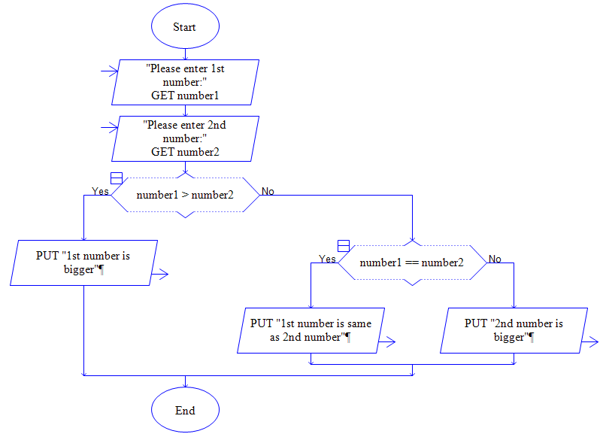

Appendix B
